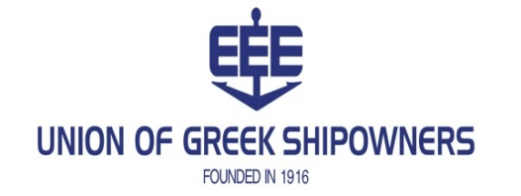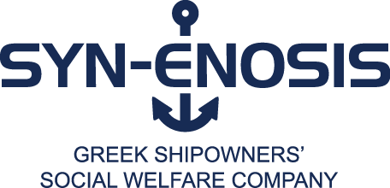

PRESS RELEASE
Piraeus, 30.3.2020
Aid of the shipping industry in the battle against the pandemic
The Union of Greek Shipowners (UGS), through its collective body, the Greek Shipowners’ Social Welfare Company SYN-ENOSIS, with the moving response of the members of the shipping community and in close cooperation with the Greek State, which guarantees the necessity and appropriateness of the supplies, has contrived the supply of medical equipment to support the hospitals, their doctors and nurses who are fighting this unprecedent pandemic.
To date, the UGS has provided 335 medical ventilators suitable for Intensive Care Units, (ICU), 20 portable medical ventilators, 100 ICU bedside monitors and 100 ICU hospital beds as well as significant amounts of consumables for ICUs.
At the same time, it was decided to reinforce the important work performed by the Greek Police and Coast Guard personnel, protecting public health during this critical period, through various actions, such as by offering vehicles of different types and repairing the largest Navy vessel, “GAVDOS” which protects the borders in the area of Evros and the Aegean Sea, as well as by providing them with relevant consumables for their personal protection against the coronavirus.
In addition, by a joint decision of the Latsis Foundation and SYN-ENOSIS, which in recent years have been co-financing the COLLABORATE FOR HEALTH programme, all this year’s funding will now be available for the purchase of 20,000 diagnostic tests of the coronavirus for the needs of University Laboratories in Attica and Thessaloniki.
The President of the UGS and of SYN-ENOSIS, Mr. Theodore Veniamis, stated: “I would like to wholeheartedly thank all the members of our shipping family who have passionately embraced the initiative of the UGS and who, with their prompt response, have enabled our shipping industry to provide aid and support for our society and our compatriots, while remaining committed to the timeless humanitarian values of social solidarity and contribution. I wish and I hope that our country and our society will come out of this unequal war with this insidious enemy of the pandemic victorious and with the least possible human losses”.

85 AKTI MIAOULI, 185 38 PIRAEUS, TEL: + 30 210 42 91 159-65
FAX: + 30 210 42 91 166, +30 210 42 90 107, E-MAIL: ugs@ath.forthnet.gr, WEBSITE: www.ugs.gr

“More than 120 members of the shipping community have responded to our initiative. All contributions, regardless of their level, are commendable and valuable and will help save lives. We thank all our colleagues who supported this effort. Indicatively, we make reference to the contributions of Messrs (in alphabetical order):

Andrianopoulos Genie, Angelopoulos George and Panagiotis, Chandris Michael & John, Captain Vassilis & Carmen Constantakopoulos Foundation, Coumantaros John, Economou George, Efstathiou Angelos Family, Embiricos Epaminondas G.E., Fostiropoulos Family, Frangou Angeliki, Goulandris Alecos Family, Hadjioannou Polys and Nicos V., Koilakos John, Laskaridis Athanassios, Lemos Michael C., Lemos Nicholas Family, Livanos George Family, Martinos Andreas Family, Martinos Athanassios Family, Martinos Constantinos Family, Nomikos Markos Family, Palios Simeon Family, Peraticos Constantinos, Polemis Spyros L., Procopiou Dimitrios, Vardinogiannis Family,Vellis Stamatis, Veniamis Family,
Youroukos George, as well as Euronav Shipmanagement (Hellas) Ltd. and Hellenic War Risks.

The total amount raised in five days exceeded EUR 10,000,000 AND WE CONTINUE…”

